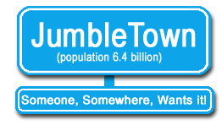©  www.jumbletown.ie  Have an item you don’t want?  Give it away on JumbleTown.ie  JumbleTown.ie is a FREE  on-line service that helps you unclutter your home or business. Simply list the item you don’t want, and wait for someone to take it off your hands…  for FREE. | War on Clutter!  JumbleTown  Needs You!

We all have items lying around the house, garden shed or workplace that we don’t need. Whether it is a piece of furniture, a computer monitor, a fridge, a bicycle, gardening tools, or even left-over building material, one thing is certain: we would all gladly part with an item that is taking up valuable space. It is also a fair bet that someone in the locality could put that item to further use, and this is where JumbleTown comes in.

Basically, JumbleTown is for anyone looking to give away or find literally thousands of useful items…for free. The website brings Givers and Takers together. Transactions can be carried out on the public forum/web page or through private email should you require more privacy.

The website’s main aim is to encourage the practice of life-cycling, which is about ensuring that the life-cycle or usefulness of an item is completed before it is discarded or recycled.

Start uncluttering today
because JumbleTown is good for
you, the community, and the environment.
www.jumbletown.ie

